**ACTIVITY 1**

**NAME : Abinaya COURSE: MOBILE COMPUTING**

**REG NO : 192421208 COURSE CODE: ITA0302**

1.Use Figma to create an interactive diagram illustrating the components of a basic cellular

system.

Aim: -

To create an interactive diagram illustrating the components of a basic cellular system

Procedure: -

1. open Figma

2. Create a new file

3. Select the Frames

4. Fill in the content that is required for presentation

5. Design Visual Elements

6. Make it Interactive

7. Add Annotations and Explanations

8. Incorporate Multimedia

9. Storyboard Animation

11. Review and edit the Prototype

12. Save and Share

Design: -

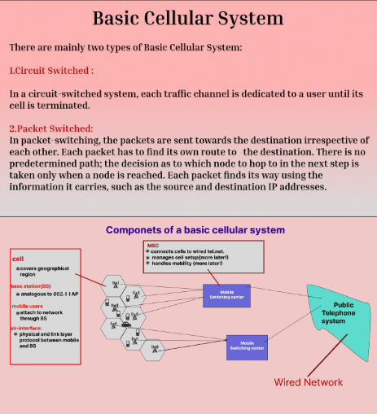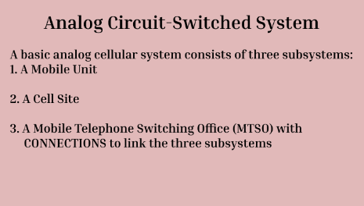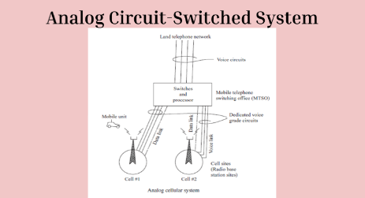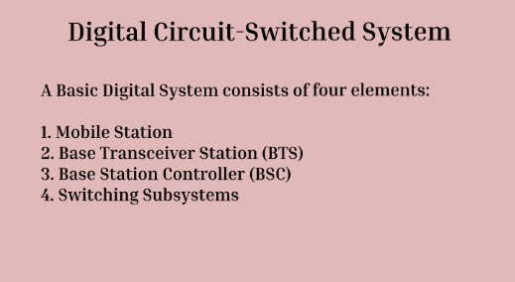

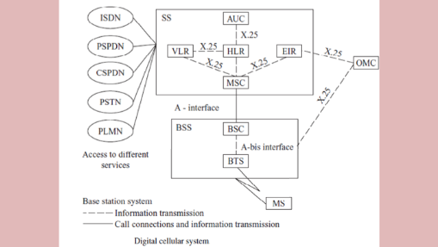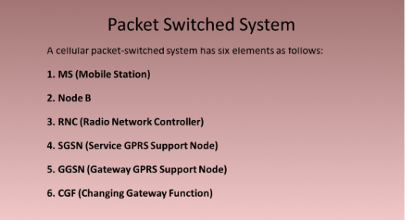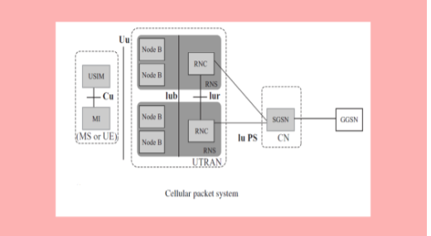

Prototype:

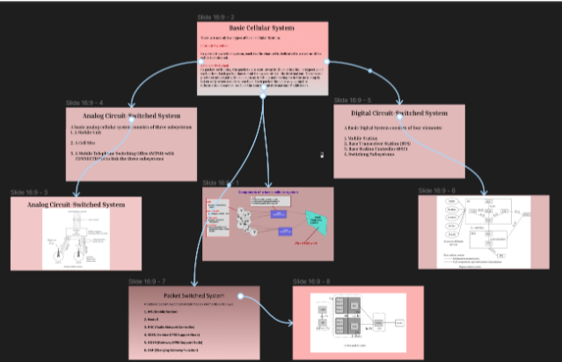

Result: -

Hence an interactive diagram illustrating the components of a basic cellular system using

Figma is created and executed successfully